Step1.

Install Jenkins on server. Download Jenkins from the official website and follow the installation instructions provided.

Step2.

Install the necessary plugins for version control integration. For example, if you're using Git, install the "Git Plugin" from the Jenkins Plugin Manager.

Step3.

Create a new Jenkins project for your application. Choose Pipeline.

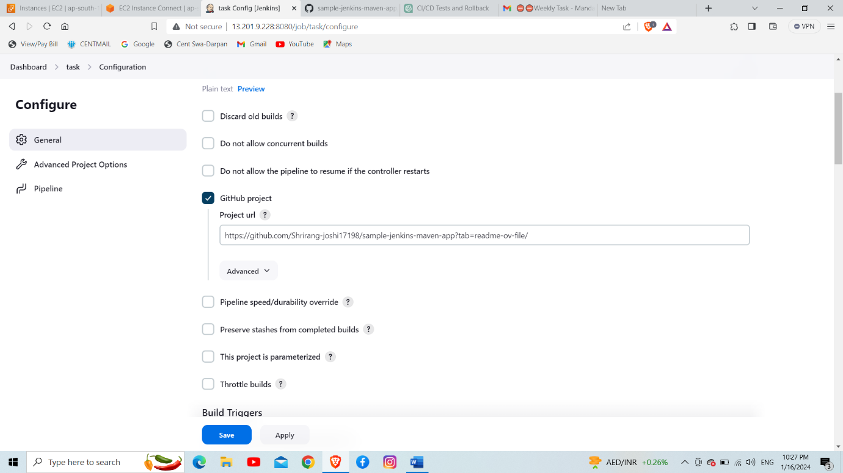

Step4.

Go to "Manage Jenkins" > "Configure Global Security".

Step5.

Configure user roles and permissions based on your requirements. You can define permissions for different job types, job configurations, etc.

Step6.

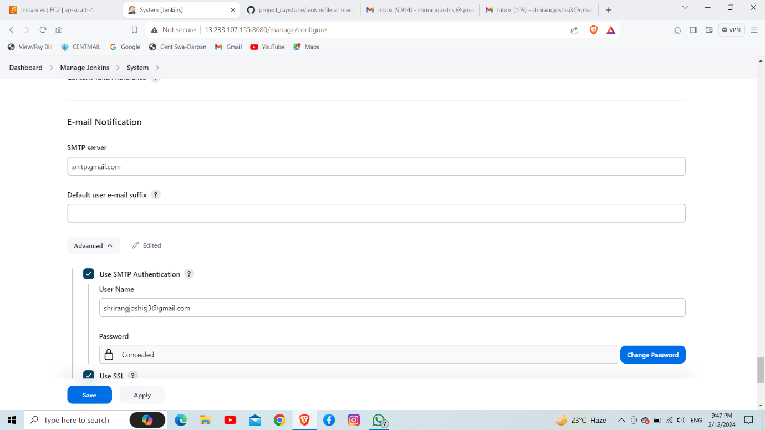

Step7.

Build the Jenkins job

